1.3 I can understand a range of tools and techniques and relate these to projects

From picking the environments to finding the right tools and techniques to put them into practise:

I have said that we are using Visual studio and Github for our web pages and have had to do lessons to learn how to do HTML and CSS in order to use them. This knowledge then leads us into knowing which techniques to use when doing projects, one technique is called Trello.

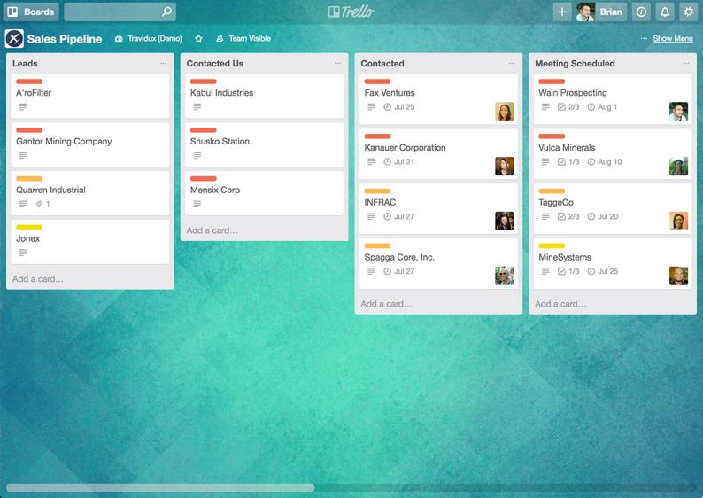

[The above photo shows an example of Trello in action]

Trello is used as a technique for people working on projects to update at each point, from design to end product after testing.

Using tools such as a laptop or a desktop to get the job done may differ depending on which programs are compatible for each of them. Programs such as GIMP or video editing software may not run on a laptop because of RAM.

When picking the technique to go with the tool, it is always good to have compatible files in order to transfer over to other people on the team, this will help the check-boxes on the Trello board to be ticked off and the project to be finished.